Driving change:
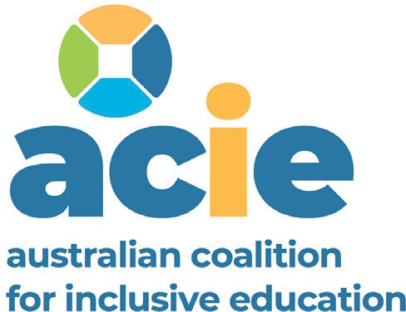
A roadmap for achieving inclusive education
in Australia
February 2021

Driving change: A roadmap for achieving inclusive education in Australia

Realising inclusive education in Australia for students with disability is essential for creating the inclusive society we all want, and lifelong benefits for children and young people.

A transformation in education is needed to ensure Australia
complies with the United Nations Convention on the Rights of Persons with Disabilities (CPRD)
All Australian children must be welcomed and supported at their local school and provided with a high quality inclusive education. Sadly, for too many children and young people with disability, this is not the case.
We know that inclusive education
is essential for creating the inclusive society to which every Australian
is entitled.
Fifty years of evidence tells us that inclusive education best prepares students with disability for life and success. But students with disability in Australia face challenges in accessing inclusive education as recognised by the CPRD, and often face discrimination, segregation from their non-disabled peers, bullying, restrictive practices and suspensions and expulsions.
The Australian Coalition for Inclusive Education (ACIE) is a national coalition bringing together organisations that share a commitment to advance inclusive education in Australia and across state and territory education systems, including government
and non-government schools.

We know that inclusive education is essential for creating the inclusive society to which every Australian is entitled.

Driving change: A roadmap for achieving inclusive education in Australia 2

Why a roadmap?
A roadmap is a journey from a starting point to an end
destination. The end destination we want is inclusive education in Australia, a fundamental human right recognised in the CPRD and defined in General Comment No.4, for all children and young people with disability, without exception.
Australia has many educational stakeholders across state and territory government and
non-government sectors, including students themselves, parents, teachers, principals, professional associations/unions, academics and more. Our starting point is that all education stakeholders want the best for students
with disability.
However, the best cannot be achieved when we have education systems that continue to overlook the human rights of students with disabilities and the strong evidence base for inclusive education.
All parts of the system need
to work together to ensure that inclusive education is achieved. While different education stakeholders are at different starting points along the roadmap to inclusive education, the end goal is very clear. Hence this is why we have developed this roadmap, Driving change: A roadmap for achieving inclusive education
in Australia. It aims to assist educational stakeholders on this journey over the next 10 years.

A note on terminology
In this roadmap we have adopted the same terms used in the CRPD General Comment No.4 Right to Inclusive Education.
Definitions in CRPD General Comment No.4 Right to Inclusive Education.

Exclusion occurs when students are directly or indirectly prevented from or denied access to education in any form.
Segregation occurs when the education of students with disabilities is provided in separate environments designed or used to respond to a particular or various impairments, in isolation from students without disabilities.
Integration is a process of placing persons with disabilities in existing mainstream educational institutions, as long as the former can adjust to the standardized requirements of such institutions.
Inclusion involves a process of systemic reform embodying changes
and modifications in content, teaching methods, approaches, structures and strategies in education to overcome barriers with a vision serving to provide all students of the relevant age range with an equitable
and participatory learning experience and environment that best corresponds to their requirements and preferences. Placing students with disabilities within mainstream classes without accompanying structural changes to, for example, organisation, curriculum and teaching and learning strategies, does not constitute inclusion.
Furthermore, integration does not automatically guarantee the transition from segregation to inclusion.
Broadly, the term ‘segregation’ is used to refer to systems, policies or practices, including but not only in education, that share the characteristic of separating a group of people, usually based on a minority attribute – such as disability – from the dominant or majority group.*
It is worth noting that throughout Australia there are many different labels applied to settings where education services are delivered to students with disability separately from students without disability (e.g. ‘special school’ ‘specialist’ school or unit or classroom, ‘schools for specific purposes’, ‘special developmental’ schools, ‘education support’ units, ‘flexible learning’ centres, ‘learning studios’, ‘learning support’ centres, ‘multi categorical’ classes, diverse learning programs, learning enrichment centre, resource centres, disability units, and even ‘inclusive learning’ units and others).

*In December 2020, disability rights and advocacy organisations endorsed a position paper asking the Disability Royal Commission to actively work toward the goal of ending the segregation of people with disability in schools, housing and workplaces.
For more information and to endorse access www.dpoa.org.au/endsegregation

Driving change: A roadmap for achieving inclusive education in Australia 3

Our roadmap for change

Inclusive education recognises the right
of every child and young person – without exception – to be welcomed as a valued learner and genuinely included in general education. It involves ensuring that learning environments and teaching approaches

Prevent suspensions and expulsions
Phase out segregated education

Ensure inclusive education

Increase educational outcomes

Stop

support full participation of all children and young people on an equal basis regardless of individual attributes or characteristics.
Eliminate restrictive practices
gatekeeping and other discrimination

Our Roadmap for achieving inclusive education in Australia is underpinned by six key pillars to help realise inclusive education
in Australia and prevent the violence, abuse, neglect and exploitation of students with disability.
These pillars are drawn from
the evidence base and embed the rights of students set out in the United Nations (UN) Convention on the Rights of Persons with Disabilities (CRPD).
The Roadmap for achieving inclusive education in Australia has two key sections: the outcomes that need to occur, stepped out over the next 10 years, and the key levers for change needed to realise these outcomes.

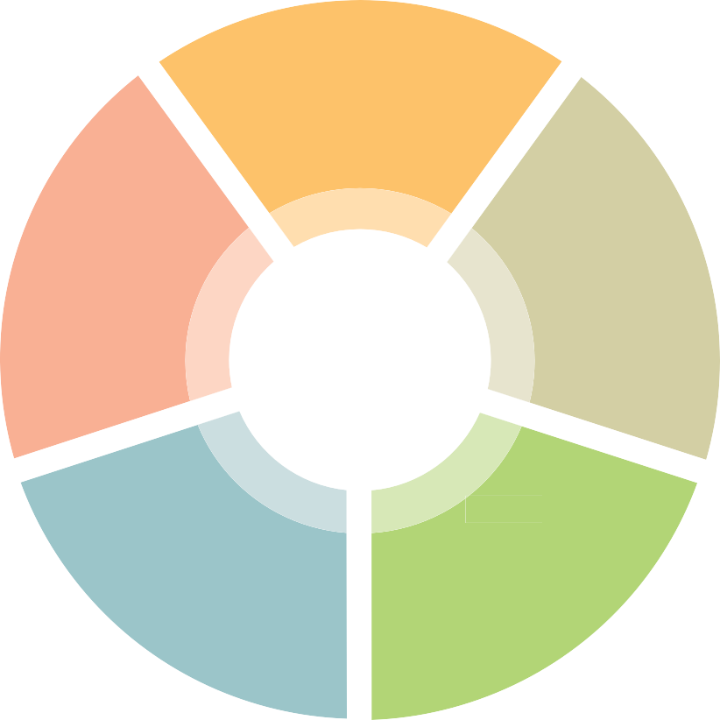

Driving change: A roadmap for achieving inclusive education in Australia 4

 1

Outcomes required to realise inclusive education and prevent violence,
abuse, neglect and exploitation of students with disability

Driving change: A roadmap for achieving inclusive education in Australia 5

Ensure
Short-term outcomes (1–2 years)

inclusive education

Inclusive education recognises the right
of every child and young person – without exception

– to be welcomed as a valued learner and genuinely included in general education.
It involves ensuring that learning environments and teaching approaches support full participation of all children and young people on an equal basis regardless of individual

attributes or characteristics.1
Pre-service teaching units and assessment adequately embed inclusive education principles across curriculum delivery, including universal design for learning and quality differentiation.
There is widespread and high quality teacher and principal professional development in inclusive education.
The Australian and state/territory governments have agreed to a
- year Inclusive Education Plan, developed alongside people with disability, experts and advocates.
There is a positive narrative for inclusive education as an expectation and human right, which includes positive media coverage for students, teachers, schools and the broader community.
Students, parents, unions, professional associations and education system employees can all articulate what
inclusive education is – and what it isn’t – in line with the UN CRPD.
Principals, teachers, professional associations and unions are advocating for all elements of inclusive education and no further investment in segregated settings.
The components, evidence and benefits of inclusive education are well known and able to be described by teachers and principals.
‘Integration’ approaches in general education are recognised as inadequate and distinguished from inclusive education.
Families have robust, transparent and independent complaints mechanisms when their child does not experience inclusive education (e.g. an independent tribunal or commission established by national harmonised legislation and implemented locally).

Medium-term outcomes (3–5 years)

  - The CYDA fact sheet is drawn from the 2019 report Towards inclusive education: a necessary process of transformation. It was written by Dr Kathy
States and territories have a transparent improvement framework for inclusive education that is rigorously monitored and reported against, with an independent national oversight body/commission overseeing this work.
Schools and school systems are held accountable for inclusive education (e.g. via a transparent and independently assessed scorecard of schools).
National data are collected on the experience of students with disability in inclusive education
(or not) from existing and new sources across a range of data points:
- student voice and satisfaction
- attendance
- learning and engagement
- educational achievement
- post-school transition and outcomes
- accessibility, support and adjustments
- funding provided and spent
- inclusive education Key Performance Indicators (KPIs) monitoring change over time.

Cologon, Department of Educational Studies,
Macquarie University for Children and Young People with Disability Australia.

Long-term outcomes (5–10 years)

Inclusive education is normalised in practice for students with disability.

Driving change: A roadmap for achieving inclusive education in Australia 6

Phase out
Short-term outcomes (1–2 years)

segregation
A target is set that by 2023 there are no new enrolments of students entering the first year of primary school in special school, or special
Segregated education does
not provide a pathway to an inclusive life for people with disability.

Segregated education is not inclusive education.

As the United Nations’ CRPD states, “segregation occurs when the education of students with disabilities is provided in separate environments designed or used to respond to a particular or various impairments, in isolation from students without
disabilities.”2

units/special classes in ‘mainstream’ schools.
There is research (quantitative, qualitative and longitudinal) on the consequences of segregated and non-inclusive education and its impact on:
  - emotional and mental wellbeing of students
  - academic achievement, attainment and outcomes
  - employment pathways
  - health outcomes
  - housing solutions
  - juvenile justice
  - complementary and compensating support services
  - life expectancy
  - lifetime costs.
To identify system issues and barriers, there is independent research into the factors that families have taken into account when choosing segregated education.
The Australian and state/territory governments lead the development of and commitment to a plan to phase out segregated education
for all students, which includes milestones, key performance indicators, and monitoring and accountability.
The transition timetable is child-centred.
There is a commitment to no new investment in segregated infrastructure at a state/territory or national level.
There is broader application of existing and new models of best-practice teaching and
educational practice to support inclusion of all students.
New models have been co-designed with young people with disability, and they are involved in the change as paid community advocates.
There is funded individual advocacy and support for the transition for students and families.
The community, families, educators (including early childhood) and education system leaders recognise that segregation is not effective and there is support for the transition to inclusive education.
Existing support programs and services are refocused to promote de-segregation and transition (e.g. My Time funding, Inclusion Support Program (early childhood and before and after school care), the National Disability Insurance Scheme (NDIS), Early childhood funded services).

  - Paragraph 12 of General Comment No.4 calls for ‘ending segregation within educational settings by ensuring inclusive classroom teaching in accessible learning environments with appropriate supports’ and for inclusive education to be ’monitored and evaluated on a regular basis to ensure that segregation or integration is not happening either formally or informally’, paragraph 13 states that ’the right to non-discrimination includes the right not to be segregated and
to be provided with reasonable accommodation’, paragraph 39 provides that the full realisation of Article 24 ’is not compatible with sustaining two systems of education: mainstream and special/segregated education systems’ and paragraph 68 calls for ’a transfer of resources from segregated to inclusive environments’.

Driving change: A roadmap for achieving inclusive education in Australia 7

Phase out
Medium-term outcomes (3–5 years)

segregation
There are no new enrolments
in special schools in primary and secondary levels (via a grandfathering method), and special units/special classes in ‘mainstream’ schools
are closed.
There are policies and legislation in place to support a reduction in segregated education over time, including changes to state and territory legislation that currently
supports ministerial (or equivalent) enrolment override.
The rights of students with disability to inclusive education is reflected
in education policy and practice, and the myth of parental choice in segregation is debunked.
It is widely understood by parents, educators and the community that transition to inclusive education is achievable and should not be feared.
There is no further investment nationally or in the states/territories in a dual-track education system that segregates students with disability, and current specialised settings are re-purposed for general student populations.

Long-term outcomes (5–10 years)

Segregated education no longer exists in Australia.
All primary and secondary schools are welcoming and inclusive of students with disability, with measured improvement in academic achievement and employment outcomes.

Driving change: A roadmap for achieving inclusive education in Australia 8

Improve
Short-term outcomes (1–2 years)

educational outcomes

Students with disability

in Australia experience considerably poorer educational outcomes than non-disabled students.

Around a third of people with disability aged 20

or over have completed Year 12-level schooling – compared with 62 per cent

of people without a disability.
The school community embraces all learners and the value of students with disability to all learners is
well known.
The role of teachers’ aides in the Australian school system is independently reviewed, with
recommendations for the future to ensure strong educational outcomes based on research and best practice.
All students with disability experience high learning and development expectations and have an Individualised Educational
Learning Plan. This plan is developed in consultation with the family,
the student and the school.
All pre-service teacher training includes universal design for learning and how to differentiate curriculum for students with disability, and there is upskilling of the current teaching workforce.
The Australian Curriculum embeds universal design for learning principles and provides examples and modelling of how to differentiate curriculum.
The educational outcomes and post-school pathways of students
with disability are routinely collated and publicly reported.
The relationship between educational outcomes and being
a valued member of the school and class community is well known, and efforts to improve are articulated
in school improvement planning.
Students with complex communication needs (CCN) are supported in their right to a comprehensive communication
system relevant to their individual requirements, allowing them to participate, access the curriculum, learn and achieve with equity.

Medium-term outcomes (3–5 years)

Best practice in educating students with disability is occurring in Australian schools and independently monitored through school improvement methods.
All students with disability are learning the same curriculum as their peers, reasonably adjusted and differentiated to their needs.
Universal Design for Learning principles are embedded in all aspects of education design and delivery so the class lesson is accessible to the greatest number of students and the need for individualised adjustments
is reduced.

Long-term outcomes (5–10 years)

Increased retention of students with disability until year 12.
Increased rates of young people with disability enrolled in higher education and vocational education and training.
The gap in attainment and educational outcomes for students with disability and other learners is closing.

Driving change: A roadmap for achieving inclusive education in Australia 9

Stop gatekeeping
Short-term outcomes (1–2 years)

and other
discrimination

‘Gatekeeping’ occurs when there is formal or informal denial of access or informal discouragement of children with disability attending their school of choice. It may include school staff saying that a child is better off going to another school, a special school or a school with a special unit because their school doesn’t have enough resources or the
Gatekeeping is well defined and:
- families know how to identify it, and what to do if it occurs
- there are consequences for schools that engage in gatekeeping.
Families have robust, transparent and effective mechanisms to make complaints and have them remedied at a school level, and access to an independent national oversight body/commission if the complaint
is not resolved.
Schools are required to record the number of enrolments they have refused or discouraged and the reasons why.
Families have a process to provide feedback on their enrolment experience, and systemic and individual issues are addressed.
Regional offices are working with schools to identify and understand why students with disability are not enrolled at or attending their local or closest school.
There is zero tolerance of gatekeeping in the Australian school system, with punitive consequences if this does occur.

skill to support the child.

It may also include refusing

Medium-term outcomes (3–5 years)

to enroll a child with disability, only offering part-time hours, or encouraging home-schooling.

It is discriminatory, devaluing and demeaning.
Gatekeeping does not occur.
School performance is measured by participation and inclusion and embracing all learners.
The ratio of students with disability compared to the rate in the community is reflected in school enrolments (to prevent
quasi-segregation via ‘lighthouse’ schools conducting best practice).

Driving change: A roadmap for achieving inclusive education in Australia 10

Eliminate
Short-term outcomes (1–2 years)

restrictive practice
There are clear definitions of restrictive practices in education and these are well known by educators, parents and school system employees.
There are independent senior practitioners for preventing restrictive practice in every jurisdiction and they provide expertise in alternatives to these measures.
‘Restrictive practice’ is any practice or intervention that has the effect of restricting the rights or freedom of movement of a person with disability. This can include physical, mechanical or chemical restraint. It can also include psycho-social restraint, which involves using intimidation or threats to control a person.
Restrictive practices are cruel, inhumane and degrading.

A multi-layered approach
(e.g. wrap-around supports) is developed within each school
to be responsive and proactive in supporting students to minimise the use of restrictive practices.
Cases of restrictive practice are independently investigated and reviewed to identify root causes and systemic issues.
There is an understanding of how to regulate against restrictive practices.
Data are routinely collected and transparently reported, including applications for the use of restrictive practices, unauthorised restrictive practices occurring and prevention activities.
Teachers are trained in alternative empathetic supports and approaches so that restrictive practices are eliminated.
Policies and procedures are developed to support inclusive education, as opposed to behaviour control.
Students are able to voice their concerns and be heard.
All primary and secondary schools are required to develop a plan for reducing and applying a strong human rights based standard
to restrictive practices.

Medium-term outcomes (3–5 years)

There is recognition that there is no such thing as a low or no risk restrictive practice.
There is a strong and enforceable regulatory regime to prevent restrictive practices in school.
Restrictive practices, including restraint and seclusion, are eliminated.
Stories of success in reducing and eliminating restrictive practice are shared.
There are strong consequences
for schools and educators that use restrictive practices.
Schools have developed a culture of flexibility and accommodation to support all students.

Driving change: A roadmap for achieving inclusive education in Australia 11

Prevent
Short-term outcomes (1–2 years)

suspensions
and expulsions
Data on suspensions and expulsions of students with disability are routinely collected and publicly reported across the states and territories (e.g. number of suspensions/expulsions, gender
and age of student, length of suspension, reasons, actions taken following suspension to prevent future suspensions and expulsions).
Suspensions and expulsions are familiar practices in the school experiences of students with disability, which shows the lack of understanding and support
available. Almost 15 per
cent of students with disability surveyed by CYDA
in August and September 2019 had been suspended
in the previous 12 months; 1.8 per cent were expelled.3

Each state and territory is required to have policies and practices
that seek to reduce and eliminate suspensions and expulsions for students with disability, taking
a whole-school approach.
Legislation is enacted in each jurisdiction to prevent suspensions and expulsions of students with disability.
Families have robust, transparent and independent complaints mechanisms to appeal and complain about suspensions and expulsions.
Schools and teachers are trained to prevent in-school and out-of-school suspensions and expulsions, and
to make adjustments and modifications to keep students engaged in their learning.
When a student is suspended more than once, an independent investigation is undertaken to ensure the school’s compliance with policies.
The impact of suspensions and expulsions on students is captured (e.g. student voice).

Medium-term outcomes (3–5 years)

The number of suspensions and expulsions of students with disability is decreasing.
Schools and school systems are held accountable for reducing suspensions and expulsions of students with disability (e.g. via a scorecard of schools that is transparent).
School suspensions are only considered as a last resort for the most serious behavioural
transgressions and in response to grave risks to health and safety.

Long-term outcomes (5–10 years)

  - Children and Young People with Disability Australia (2019) Time for Change: The state of play for inclusion of students with disability, Results from the 2019 CYDA National Education Survey
All students with disability are wholly included full-time, or there is a short-term plan to get them back to school full-time.

Driving change: A roadmap for achieving inclusive education in Australia 12

 2

Key levers for change

Driving change: A roadmap for achieving inclusive education in Australia 13

Key levers for change

All our children deserve better and the Disability Royal Commission is now giving us the opportunity to bring to light these wrongs and make long overdue changes to the education system.
- Legislative/policy change

Recommendations
  - All law and policy reform should comply with the CRPD.
  - Review the Disability Discrimination Act, noting that anti-discrimination legislation can only go so far in helping to realise inclusive education.
  - Meaningfully review the Disability Standards for Education, in line with the CRPD.
  - Develop a National Inclusive Education Act, proactive rather than discrimination-based legislation.
  - The Australian and state/territory governments commit resources and collaborate to develop and implement a new National Disability Strategy and National Disability Agreement (NDA), which provides for inclusive education and includes:
    - the development of an endorsed 10-year Inclusive Education Plan
    - shared responsibility to improve education systems and schools to ensure inclusive education, including indicators and outcomes
    - educational improvement targets and outcomes for students with disability that are reflected in the National School Reform Agreement
    - clear responsibilities for advocacy outside of the NDIS, including individual advocacy for families and young people with disability.
- Reform school funding models and move to functional needs-based funding (e.g. the Tasmanian model).
- Develop a national accreditation framework for inclusive education (along the lines of the National Quality Framework for Early Childhood Education).
- Audit education legislation in states and territories and amend or develop new legislation to realise inclusive education.
- State and territory education jurisdictions develop state-based inclusive education policies (inclusive of Catholic and independent schools sectors).
- Establish an independent national oversight body/commission for complaints resolution, with
‘own motion’ powers to conduct systemic inquiries into violence, abuse, neglect and exploitation of students with disability in the education system.

Driving change: A roadmap for achieving inclusive education in Australia 14

Monitoring/accountability
– family feedback

Parent education/support

– number/proportion of students

Recommendations
  - Deliver on the Australian Government Department of Education, Skills and
Employment’s commitment to complete an evaluation of the Inclusion Support Program (ISP).
  - Commit to post-evaluation investment in the ISP linked
to indicators of outcomes, and shared responsibility to improve mainstream education services per a new NDA.
  - Invest in information to support better inclusive practice and funding to support students with disability.
  - Deliver on the Australian Government Department of Education, Skills and
Employment’s commitment to review the loading for students with disability and invest in continuous improvement of the NCCD (Nationally Consistent Collection of Data on School Students with Disability).
  - Commit to post-review investment in the NCCD linked to indicators of outcomes, and shared responsibility to improve mainstream education services per a new NDA.
  - Develop an inclusion scorecard for schools that has official status, is transparent and independently assessed (e.g. along the lines of the Australian Children’s Education and Care Quality Authority). This includes:
    - educational inclusion
    - student voice/feedback
with disability
– intersectional representation (gender, CALD, First Nations, out-of-home care, rural and remote, etc).
- Develop a National Minimum Dataset for education of students with disability (that can be analysed by state/territory, region, sector, demographic characteristics such as gender), including:
- student voice and satisfaction
- attendance
- learning and engagement
- educational achievement
- support and adjustments
- funding provided and spent
- transition to inclusive education KPIs – experience and outcomes
- retention, post-school pathways and transitions
- educational achievement (e.g. NAPLAN)
- educational adjustments (e.g. NCCD)
- intersectional data (CALD,
First Nations, out-of-home care, rural and remote, etc)
- suspensions/expulsions and restrictive practices
- number of students home-schooling.
Recommendations
- Provide further funding for independent disability advocacy for families and young people with disability, to ensure students can have their rights to inclusive education upheld.
- Invest heavily in parent education, starting early in a child’s life, so they are aware of children’s rights to and benefits and outcomes
of inclusive education and move away from thinking children need ‘special’ education.
- Support family involvement in achieving inclusive education.
- Invest in a national, state and territory-supported campaign/
a broad communications strategy to increase community understanding of the importance of inclusive education. This should include case studies, social change narratives and whole-of-community messaging.

Driving change: A roadmap for achieving inclusive education in Australia 15

Teacher education
Recommendations
  - Research and develop the evidence base of best practice models and ensure this is widely disseminated (e.g. using co-teaching and peer tutoring, rather than teachers’ aides).
  - Train teachers in team-based approaches and collaborative models to support students with disability, including family-centred practice.
  - Develop a national standard for inclusive education in pre-service teacher training.
  - Fund postgraduate qualifications in inclusive education and strategically use and reward expertise across education systems to support schools
in inclusion.
  - Increase the numbers of teachers with disability.
  - Invest in professional development for principals and teachers in inclusive education and preventing discrimination, violence, abuse and neglect of students with disability.

School cultures for inclusion

Recommendations
- Adopt approaches for teaching diverse classes using methods such as universal design for learning approaches.
- Develop resources and toolkits for families and educators on inclusive practices.
- Develop additional measures for student success other than NAPLAN and ATAR (e.g. an inclusion index).
- Reward educators and schools for good practice (e.g. through remuneration, status and profile).
- Measure and evaluate whole-of-school inclusive
practice using new and existing models.

Student agency and voice

Recommendations
  - Involve students with disability in democratic processes at the school and at regional and state/territory levels.
  - Provide accessible information that allows students to safely learn about their rights and the process to complain.
  - Develop programmatic responses for activating student voice.
  - Seek feedback from students and ex-students with disability about what works, especially from those with complex communication needs and intellectual disability.
  - Incorporate student voice in educational policy and practice.

Driving change: A roadmap for achieving inclusive education in Australia 16

The Australian Coalition for Inclusive Education (ACIE) is an initiative bringing together organisations that share a commitment to advance inclusive education in Australia and across state and territory education
systems, including government and non-government schools.

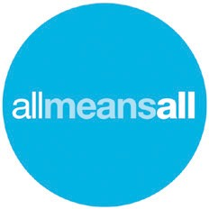

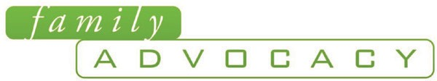


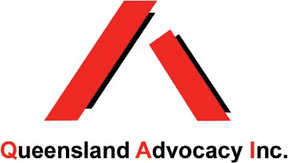
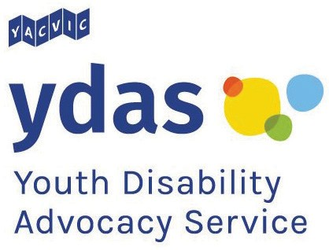
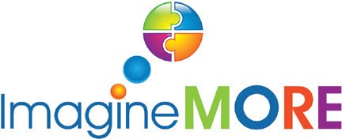


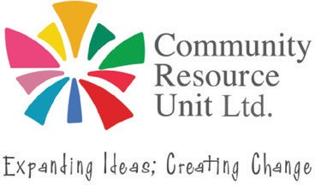

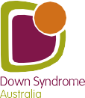
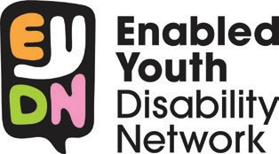

The Australian Coalition for Inclusive Education would like to acknowledge the traditional custodians of the lands on which this report has been written, reviewed and produced, whose cultures and customs have nurtured and continue to nurture this land since the Dreamtime. We pay our respects to their Elders past, present and future.
This is, was, and always will be Aboriginal land.

Driving change: A roadmap for achieving inclusive education in Australia
developed by the ACIE is endorsed by the following organisations.


